**Planning Phase**

**Purpose**

The primary objective of my portfolio is to garner the attention of like-minded individuals and potential clients or employers along with documenting my growth in web development. This may include showcasing my skills and achievements, enhancing my personal brand, or facilitating a job search.

**Target Audience**

The intended audience for my portfolio are people that want me for my skills in web development. This could encompass potential employers, clients, peers, or a specific industry.

**Project**

**Purpose:**

This is an online sneaker store website whose purpose is to provide its users a great experience when shopping online for sneakers.

**Target Audience:**

The target audience for this project includes mainly youngsters that wish to buy the latest trendy sneakers at good rates. The interface is intuitive and catchy and something that the youngsters of today will definitely appreciate. The sneaker market is something that a lot of people overlook but it is one of the most profitable businesses today with many shoes going for thousands of dollars.

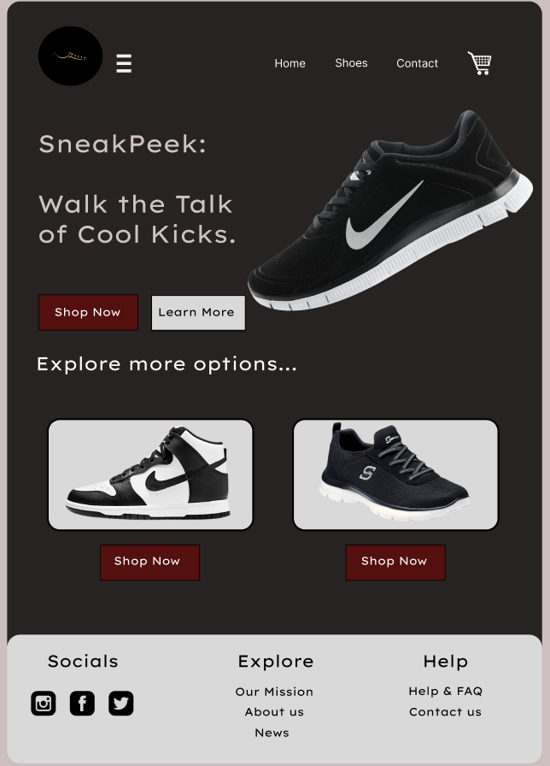**Design snapshots:**

